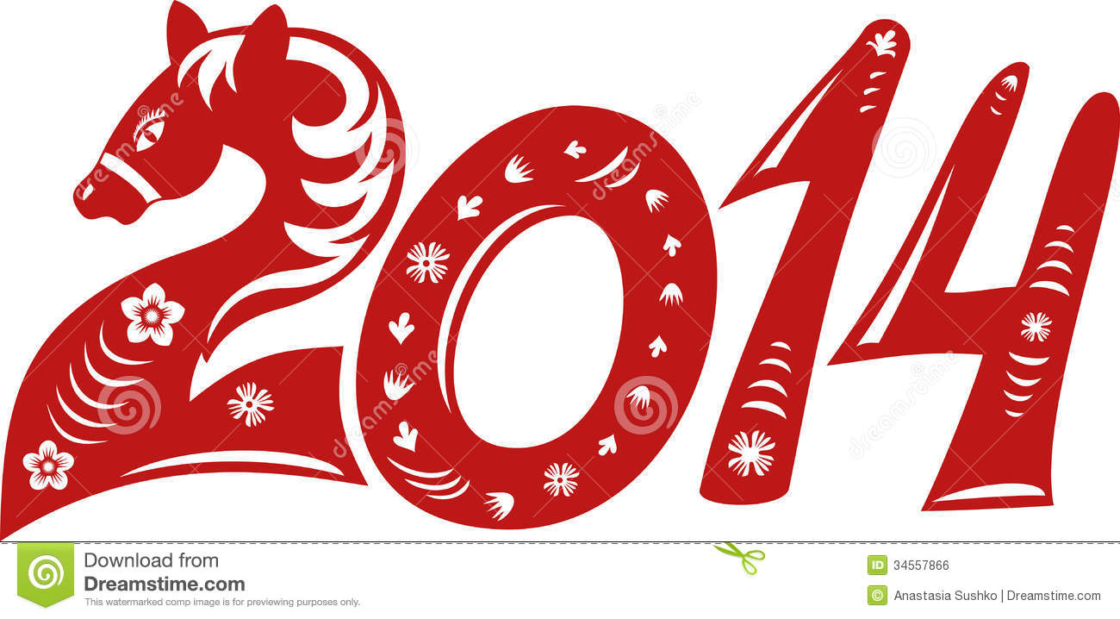
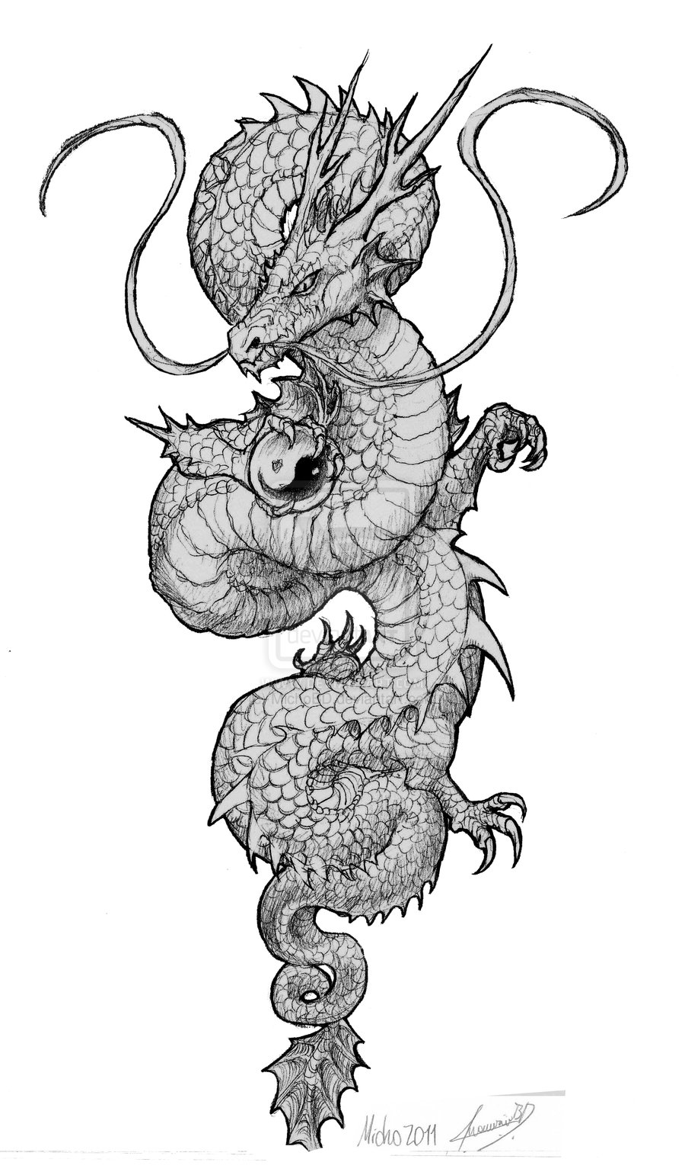
Happy Chinese New Year! “Gung hay fat choy!”
Student B
Part of the Chinese Zodiac – animals represent years
Horse | Sheep/goat | Monkey | Rooster | Dog | Pig
1954 | 1955 | 1956 | 1957 | 1958 | 1959
1966 | 1967 | 1968 | 1969 | 1970 | 1971
1978 | 1979 | 1980 | 1981 | 1982 | 1983
1990 | 1991 | 1992 | 1993 | 1994 | 1995
2002 | 2003 | 2004 | 2005 | 2006 | 2007
2014 | 2015 | 2016 | 2017 | 2018 | 2019

Characteristics of animals and people born in their year
Horse | Lots of energy, popular, like large crowds, want freedom, like to travel
Sheep | Creative, imaginative, artistic, often shy, usually religious
Monkey | Like to have fun, like stimulation, skillful, have good memories
Rooster | Truthful, quick thinkers, like tradition, like to be busy
Dog | Physically active, honest, faithful, excellent in business
Pig | Intelligent, have good manners, enjoy learning, like to help others

Ask your partner questions to find the answers:
Last year was the year of the ___________________________________________. (when?)
This animal is lucky with money. _________________________________________ (which?)
1950 was the year of the __________________________________________. (which?)
This animal likes to gossip. _____________________________________________ (which?)
Which animal represents your year of birth? ___________________________________
What are the characteristics of the animal that represents your birth year?
_________________________________________________________________________________________________
Do you agree or disagree with these characteristics? Explain.
_________________________________________________________________________________________________
Talk with your partner; choose a girlfriend/boyfriend/brother/sister/ and find their animal. Do you agree with the characteristics of that person?
For example, my brother was born in 1978, so he is a horse. He has lots of energy and likes to travel, but he is not popular and likes to be alone.
Happy Chinese New Year! “Gung hay fat choy!”
Student A
Part of the Chinese Zodiac – animals represent years
Rat | Ox | Tiger | Rabbit | Dragon | Snake
1948 | 1949 | 1950 | 1951 | 1952 | 1953
1960 | 1961 | 1962 | 1963 | 1964 | 1965
1972 | 1973 | 1974 | 1975 | 1976 | 1977
1984 | 1985 | 1986 | 1987 | 1988 | 1989
1996 | 1997 | 1998 | 1999 | 2000 | 2001
2008 | 2009 | 2010 | 2011 | 2012 | 2013

Characteristics of animals and people born in their year
Rat | Hard working, clever, charming, have big ambitions, loyal
Ox | Patient, calm, trustworthy, easygoing, quiet
Tiger | Courageous, proud, powerful, leader, well respected
Rabbit | Gentle, shy, sensitive, kind, like to entertain, gossip, lucky with money
Dragon | Healthy, powerful, brave, energetic, leader
Snake | Generous, like to help others

Talk to your partner and ask questions to find the answers:
This year is the year of the ___________________________________________. (when?)
This animal is usually religious. _________________________________________ (which?)
1969 was the year of the __________________________________________. (which?)
This animal has a good memory. _____________________________________________ (which?)
Which animal represents your year of birth? ___________________________________
What are the characteristics of the animal that represents your birth year?
_________________________________________________________________________________________________
Do you agree or disagree with these characteristics? Explain.
_________________________________________________________________________________________________
Talk with your partner; choose a girlfriend/boyfriend/brother/sister/ and find their animal. Do you agree with the characteristics of that person?
For example, my brother was born in 1978, so he is a horse. He has lots of energy and likes to travel, but he is not popular and likes to be alone.

